Dairy Dictionary
Antibiotics 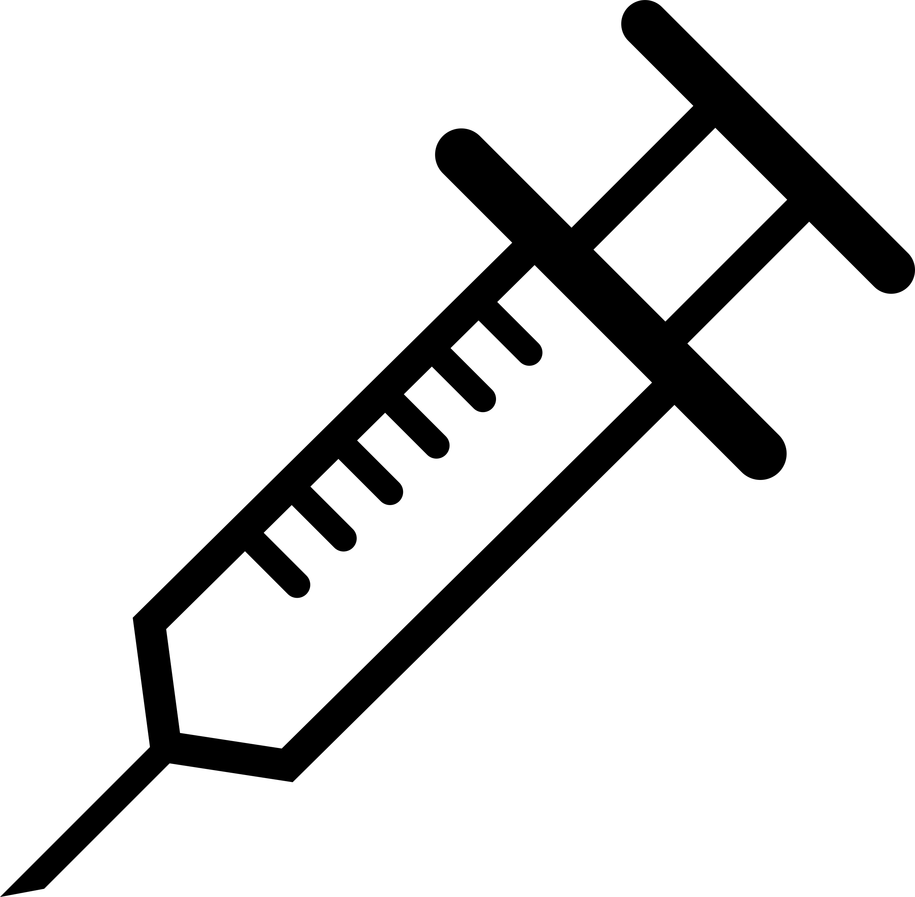
Medication that kills or slows the growth of harmful bacteria. Farmers give antibiotics to treat cows that are ill, just as humans sometimes need medication when they are sick. Milk from a cow being treated is separated to ensure it does not go into the milk supply.
Ayrshire 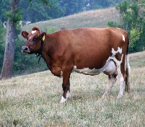
A breed of dairy cattle that originated from the County of Ayr in Scotland. The average mature Ayrshire cow weighs between 1,000 and 1,300 pounds and has red markings that can vary in color from orange to brown.
Bedding 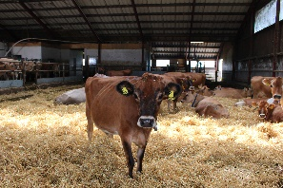
Material used to absorb moisture and provide a comfortable cushion where cows can rest. Possible bedding materials include straw, sawdust, wood chips, sand, ground limestone, separated manure solids, shredded newspaper, corn stalks, bark, peanut hulls, sunflower hulls, and rice hulls.
Bovine 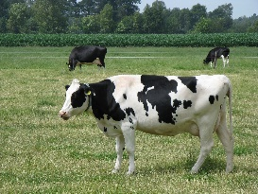
Of the biological subfamily Bovine. This diverse group features about 24 species of medium sized to large ungulates (animals with hoofs), such as domestic cattle. Other members include bison, water buffalo and yak.

Brown Swiss 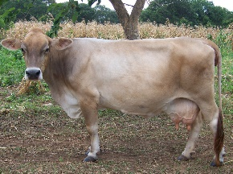
A breed of dairy cattle that originated in the Swiss Alps and produces the second largest quantity of milk annually of any dairy breed. Their milk averages 4 percent butterfat and 3.4 percent protein, which makes it ideal for cheese production. Brown Swiss are gray-brown in color and are known for their docile temperament.
Bulk Tank 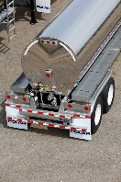
A refrigerated, stainless steel storage tank located at dairy farms, designed to hold milk as soon as it leaves the cow through a series of pipes that travel from the milking parlor to the tank. The milk is cooled immediately in the bulk tank, usually to 35-39 degrees.
Bull 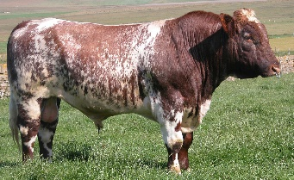
An adult male dairy animal.
Butter 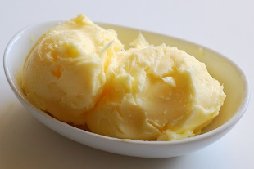
Butter is produced by churning the fat from milk or cream until it solidifies. It may then be salted.
Byproducts 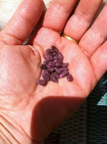
The derivatives resulting from processing other foods and fibers. Dairy farmers routinely feed their cows byproducts such as citrus pulp, cotton seed, brewer’s grains, molasses, and almond hulls that are recommended by animal nutritionists who work with dairy farmers on creating menu plans to provide healthy diets for cows.
Calf 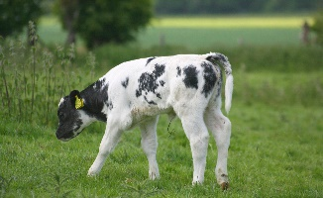
A young female dairy animal before she has matured. A young male is called a bull calf.
Colostrum 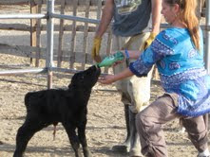
The first milk given to calves in the first 24 hours of life by a dairy cow following birth. Colostrum is rich in fat and protein and has immunity elements.
Cow 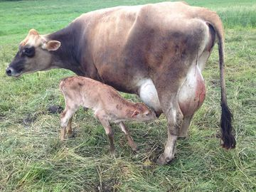
A mature female of cattle that has delivered a calf, usually around 2 years of age.
Cream 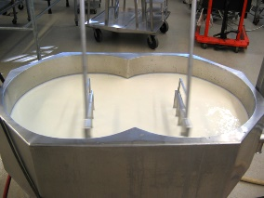
The high-fat portion of milk that is separated during processing. Cream is used to produce products such as ice cream, half and half, and whipping and heavy cream. Cream also is dried and powdered, and some is condensed by evaporation and canned.
Cud 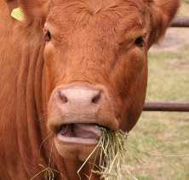
The partially digested food that is regurgitated from the first compartment of the cow’s stomach into the mouth to be chewed again. A cow may spend seven hours a day eating food and an additional 10 hours a day chewing her cud.

Dairy Nutritionist 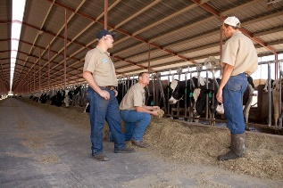
Professionally trained and educated animal health consultants who specialize in the nutritional needs of dairy cows. Nutritionists recommend the optimal, scientifically balanced diets that are designed for the specific needs of different cows. Nutritionists work with farmers to monitor how cows respond to their customized feeding programs.
Dam 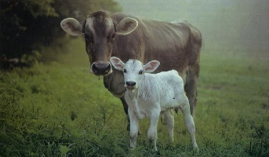
The mother of a calf.
Dry Cows 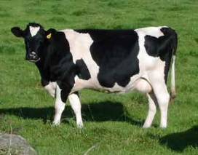
A segment of time during which a cow is not producing milk. The “dry” period lasts between 50 and 70 days when a cow is preparing to give birth to a calf, which then begins a new lactation period.
Ear Tag 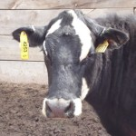
A device like an earring that dairy farmers place in the ears of their animals to identify each member of the herd. Ear tags contain a number that is given to a cow and allows the dairy farmer to maintain accurate health and milk production records.
Forage 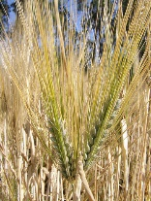
Cow feed that is high in fiber, such as whole plants of corn, small grains (such as oats, barley, or wheat), legumes, and grasses.
Freestall Barn 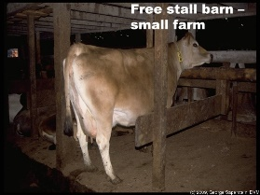
A modern barn that houses and protects the dairy herd and provides a comfortable resting area. It includes individual stalls and bedding for each cow, and access to clean water and feed 24 hours a day. Freestall barns provide optimal ventilation and many are climate controlled, allowing for cow cooling measures such as misters and fans in the summer and curtains and sidewalls for the winter. Cows are not restrained and are free to enter, lie down, rise, and leave the barn as they desire.
Fresh Cow 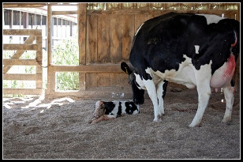
A cow that has recently given birth to a calf.
Guernsey 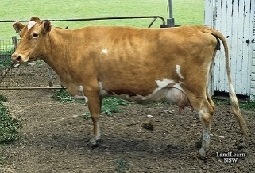
A small, cream-and-brown breed of dairy cattle that produces more milk per unit of body weight that any other breed. Guernsey’s are renowned for their high butterfat content of their milk. The Guernsey was bred on the British Channel Island of Guernsey and descended from cattle stock brought from nearby Normandy.
Hay 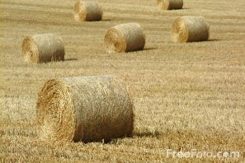
Dried feed such as rye, alfalfa, clover, grass, and oats, which is used as a food source for dairy cows. A hay field is mowed, and the trimmings dry in the sun for two to three days. (Also see Forage & Silage)
Heifer 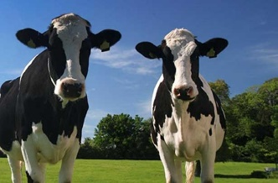
A female dairy animal that has yet to give birth to a calf.
Herd 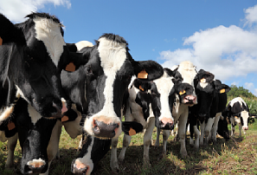
A grouping of cows on a dairy farm. Cows are often placed into herds with other cows of their age or milking status, such as dry cows and heifers.
Holstein 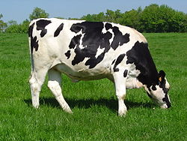
A black and white dairy cow (through there also are “Red Holsteins”) that is the most predominant breed of dairy cattle worldwide and represent approximately 90 percent of dairy cows in the United States. The Holstein originated in the province of Friesland, The Netherlands. They are known for having the highest milk production of all dairy cattle breeds.
Homogenization 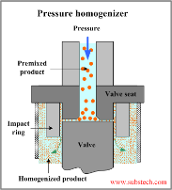
A process applied to milk that results in fat globules being reduced in size to allow a smooth consistency.
Hoof Trimmer 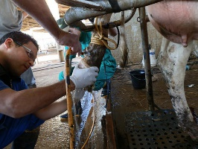
A trained professional who specializes in the trimming of a cow’s hooves on a regular basis to maintain comfort. Hoof trimmers are trained to detect disease, injury or other hoof related problems and can advise farmers on treatments.
Irrigation 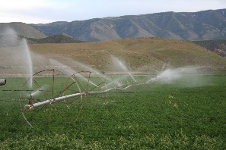
The replacement of supplementation of rainfall with water from another source to grow crops. Irrigation sources include a nearby or distant body of water such as a river, spring, lake, aquifer, well or snowpack. The water can be directly channeled to the fields or stored in a reservoir for later use.
Jersey 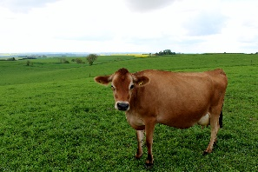
A breed of dairy cattle that is renowned for the high butterfat content of its milk. Jersey cows are smaller than other breeds (800 to 1,200 pounds) and are known for their big eyes, honey-brown color and docile natures.
Lactation 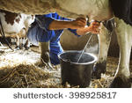
The secretion of milk from the cow’s udder.
Lagoon 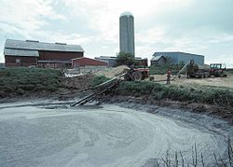
An on-farm storage basin for cow manure that is dug into the ground like a pond and lined to prevent absorption into the earth. Manure is mixed with water to provide a natural fertilizer for crops that are grown to feed cows.
Livestock Veterinarian 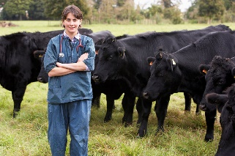
Animal doctors who have earned a degree in veterinary medicine. Sometimes called “large animal veterinarians,” many specialize in the treatment of dairy cows and work directly with dairy farmers to ensure healthy herds.
Milking Machines 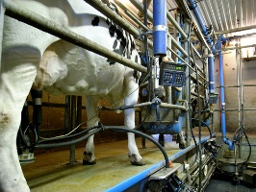
Machinery used on the farm to extract milk from cows. Electronic milking machines use a pulsating vacuum that simulates the effect of a suckling calf. The machines do not cause any harm or discomfort to the cows and they keep the milk safe from external contamination.
Milking Parlor 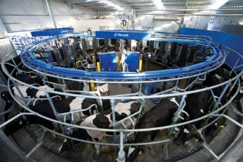
A specialized area on the dairy farm where cows are milked two or three times a day. Equipment delivers the milk directly from the cows to a refrigerated holding tank to preserve freshness and safety. The milk is then quickly transported to the dairy plant. Parlors come in many types, including flat barn, herringbone, parallel, swing, walk-through and rotary.
Milk Shorthorn 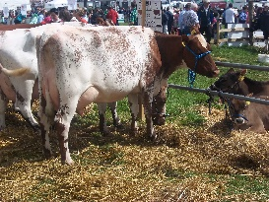
A breed of reddish-brown and white dairy cattle that originated in Britain. They are large in size.
Pasteurization
A simple, effective method to kill harmful pathogens through heat treatment without affecting the taste of nutritional value of milk. Pasteurization is recognized around the world as an essential tool for protecting public health since it was first introduced in 1864. The process was named after French scientist Louis Pasteur.
Pasture 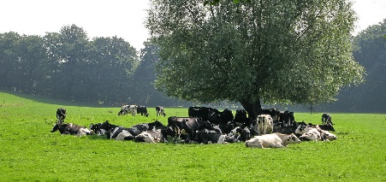
Land at a dairy farm that is lush with grasses or legumes and is used for grazing dairy cows.
Processing Plant 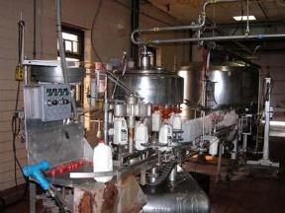
A facility that pasteurizes, homogenizes and packages/bottles milk that comes directly from dairy farms. Once milk leaves the plant, it is available to the public through a variety of channels, including grocery stores, schools and restaurants.
Replacement Heifers 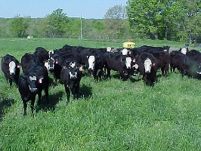
Female dairy animals that are raised with the intent of eventually replacing the cows currently in the milking herd.
Ruminant 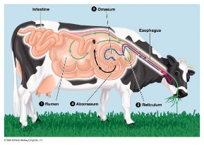
Any hooved animal, such as a dairy cow, that digests its food by first eating the raw material and then regurgitating a semi-digested form known as cud. These animals then eat their cud, a process called ruminating. Other ruminants include goats, sheep, camels, llamas, giraffes, bison, buffalo, and deer.
Silage 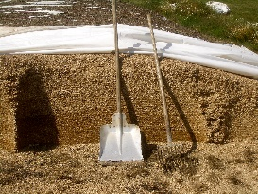
Fermented, high-moisture forage that is eaten by grazing animals such as dairy cows. Silage is most often made from grass crops such as corn or sorghum and retains a great deal of the nutrients present in the plant.
Silo 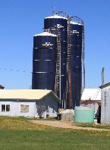
A storage facility on farms that is designed to store silage.
Sire 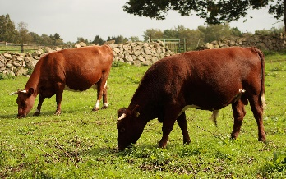
The father of a calf.

Skim Milk 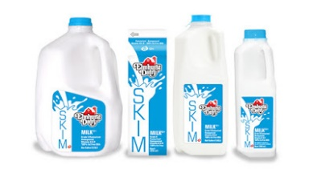
The product left after the cream is removed from milk. Skim or skimmed milk also is called fat-free milk.
Teat 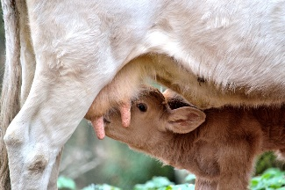
The cow’s udder contains four teats that function as the exit for milk.
Total Mixed Rations (TMR) 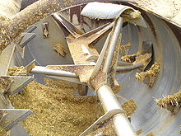
A nutritionally-balanced blend of forage and grain ingredients mixed by a machine to specific rations. This method allows cows to consume the desired proportion of forages when two or more forages are offered.
Udder 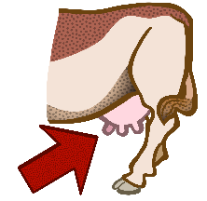
A bag-shaped body part on the underside of a female cow in which milk is formed and stored.
Veterinarian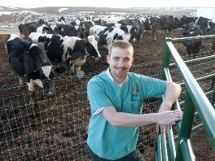
Animal doctors who have earned a degree in veterinary medicine. Sometimes called “large animal veterinarians” or “livestock veterinarians,” many specialize in the treatment of dairy cows and work directly with dairy farmers at their farms to ensure healthy herds.

